# CS 255 System Design Document

## UML Diagrams

### UML Use Case Diagram

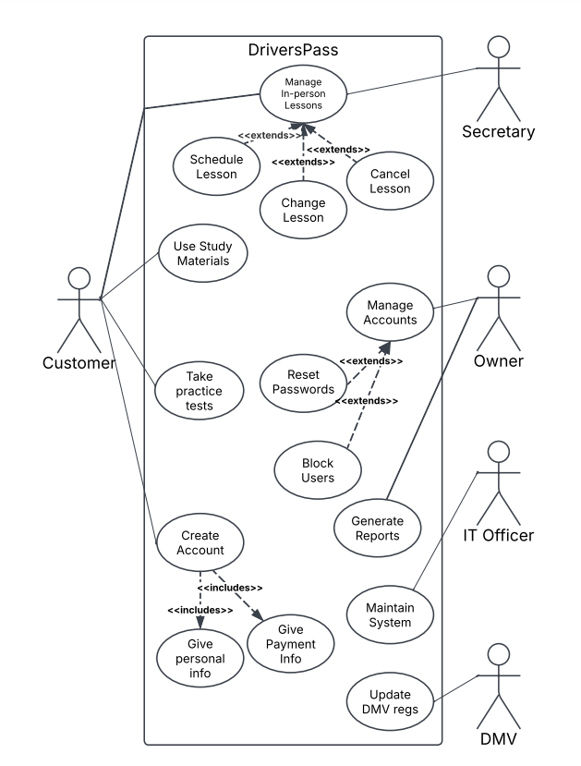

### UML Activity Diagrams

### 

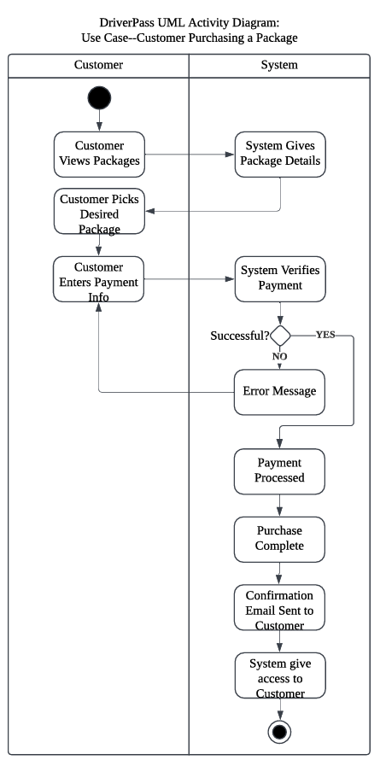

### UML Sequence Diagram

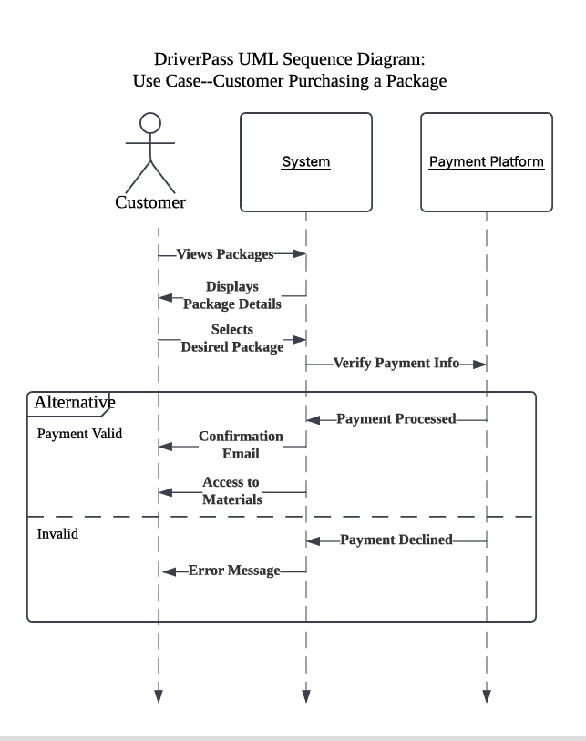

### UML Class Diagram

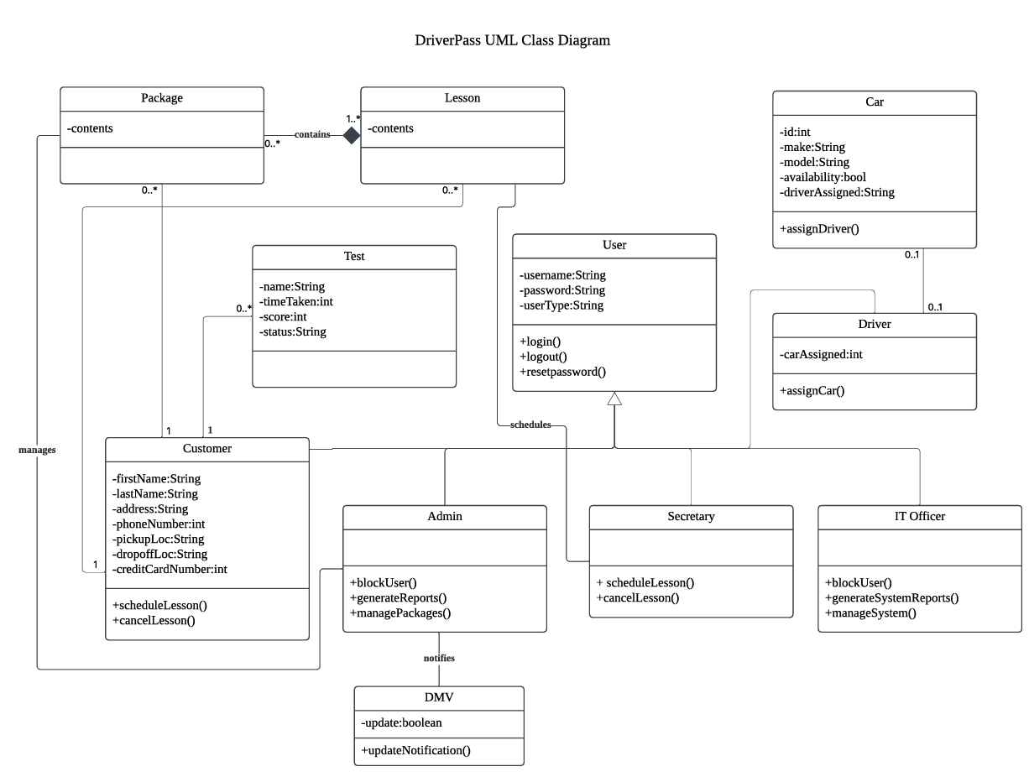

## Technical Requirements

DriverPass requires robust hardware and software to get up and running. This includes servers capable of hosting the site and database with enough storage to handle user data. The system should be accessible on various devices like computers and smartphones, so it will have to be adaptable. A reliable network with enough bandwidth is essential for uninterrupted communication. On the software side, a stable operating system like Windows is needed, along with a database management system such as MySQL. Additionally, integrating a secure payment gateway like PayPal is crucial. Using cloud services could also offer scalability and efficiency while lightening the backend management for the DriverPass team. Furthermore, DriverPass needs specific tools for development, including an integrated development environment (IDE). Whichever infrastructure is chosen should prioritize security such as firewalls and encryption to protect sensitive data like student test results and credit card information, and regular backups are essential for disaster recovery.